Karl Pytte

1002418

Abstract

A turn-based medieval business simulator designed to teach Accounting and Finance

Accountants Creed

Game Specification Document

Contents

Synopsis 2

Philosophy 2

Story 2

Mechanics 2

Win & Lose States 3

Gamespace 4

Overworld Map 4

Town 5

Project Milestones 6

Technical Details 6

References: 8

# Synopsis

This is a turn-based, 3/4view tactics game with a comprehensive in-game economy, accounting-based quest system, and light RPG mechanics, aimed at teaching year 11 high school students. The player must learn and navigate this economy to make money, while conducting accounting practices that parallel the system in Australia. Upon completion of this game, the player should understand the theory behind the current economic and tax systems in place within Australia, as well as intermediate accounting.

# Philosophy

Having an understanding of economics and finance is a huge advantage in the business world, and sadly many individuals are reluctant to learn as it is a topic that has traditionally been seen as intimidating and brutally dry. My game attempts to allow individuals a starting point with which to gain an understanding of the core systems and their practices, from which the player may then advance toward a state of complete mastery. This game is not designed to teach people to be accountants, but rather to understand the current economic system and gain the ability to navigate it while making informed decisions.

Furthermore, this game operates under the philosophy that current models of teaching are inefficient, not necessarily because of the content, but because individuals (especially children) are unable to engage in self-regulated learning. This game therefore attempts to take one of the more difficult to teach topics, and present it within an “endogenous fantasy” setting (Rieber, 1996). Due to this, players are encouraged to learn accounting as a mechanic of play, as opposed to learning accounting for its own sake.

# Story

The game features two main protagonists; a wandering merchant named Janet, and an accountant named Steven. Janet encounters Steven in an alleyway beset by thugs, and assists him in combat. Afterward the two introduce themselves as initiates in the merchant’s guild, and the “Order of the Red Letter. Plagued by debt, and with no name for themselves, they decide that a business partnership is perhaps the best way to ensure survival. They then wander the land, trading goods and helping the disadvantaged with their financial woes.

# Mechanics

The game seeks to marry simple RPG mechanics and accounting, with a central focus on learning. The mechanics are then, in order of importance:

* Accounting problems that represent real-world practices, these will be split into 3 distinct categories:
  + **Level 1 - Key concept quizzes**: these will teach the player and quiz them on their understanding of fundamental accounting concepts & definitions, such as “double-entry bookkeeping”.
  + **Level 2 - Indirect application quizzes:** These will challenge the player to apply their knowledge of accounting concepts by utilizing them in relation to other concepts, such as identifying correct “profitability ratios”.
  + **Level 3 – Direct application:** This stage tasks the player with preparing and interpreting financial statements, such as the “balance sheet”, to demonstrate mastery of their knowledge.

All content covered will be done so in light of the “Accounting and Finance Year 11 ATAR Syllabus” compiled by the “School Curriculum and Standards Authority” (2013).

* A money-making system that involves trade and teaches macro & micro economics:
  + **Micro**: buy, sell and trade commodities on an ever changing market to teach the effect of free-trade, as well as small business management through the logging of transactions and subsequent preparation of tax statements.
  + **Macro**: observe the flow of capital across various business types, including through separate sectors (private, government, ect) to gain an understanding of macroeconomics.
* Tactical turn-based map exploration with text-based battles, designed to teach the importance of risk management (observing risk vs. reward of tiles), insurance (purchasing weapons or mercenaries), and budgeting (managing funds in case of loss).

Alongside these central mechanics, the player has three primary resources they must manage; Time, Money and Reputation. For the purpose of explanation, the in-game currency is gold pieces (gp).

* **Time:** The game is turn-based, however this game differs slightly in that it features a time element, where each turn can alter the amount of time that passes based on player choice. For example, helping a villager with an easy quest may take 1 hour in-game time, whereas a hard quest will take 6 hours.
* **Money:** Each action will have some monetary cost associated with it, either a debit or a credit. For example, easy quests may have a payout of 50gp, whereas a hard quest may have a payout of 500gp.
* **Reputation:** Each action will have real-world consequences attached to it, causing the player to have an impact on the world based on their own professionalism and intelligent decision making.

The learning outcome from the combination of these resources is to gain an appreciation for the duality of time & money; that is to say the **opportunity cost** (2016) of the action. Reputation works alongside this model to simulate the value of **trade, exchange and interdependence** (2016) in an economic system.

# Win & Lose States

Player action through the course of the game will dictate how successful their venture becomes.

* **Victory:** The players will achieve a win state in the game if they have managed to pay off the long-term liabilities incurred by the merchant (through successful trading and profit-making schemes), as well as achieving 100 reputation with the Accountants guild (completing accounting quests).
* **Defeat:** Players will lose the game if their business becomes bankrupt (negative cash when payments are due), or they achieve -100 reputation with either the accountants guild (failing too many quests).

# Gamespace

The game has two primary gamespaces; town navigation and overworld navigation, the gamespace is strictly Discrete, with no continuous elements.

## Overworld Map

The map is what allows the player to travel between towns and exchange goods, is divided into hexes that contain data pertaining to time taken to cross, danger of ambush, chance of hazard, ect. An example would be the layout seen in Figure 1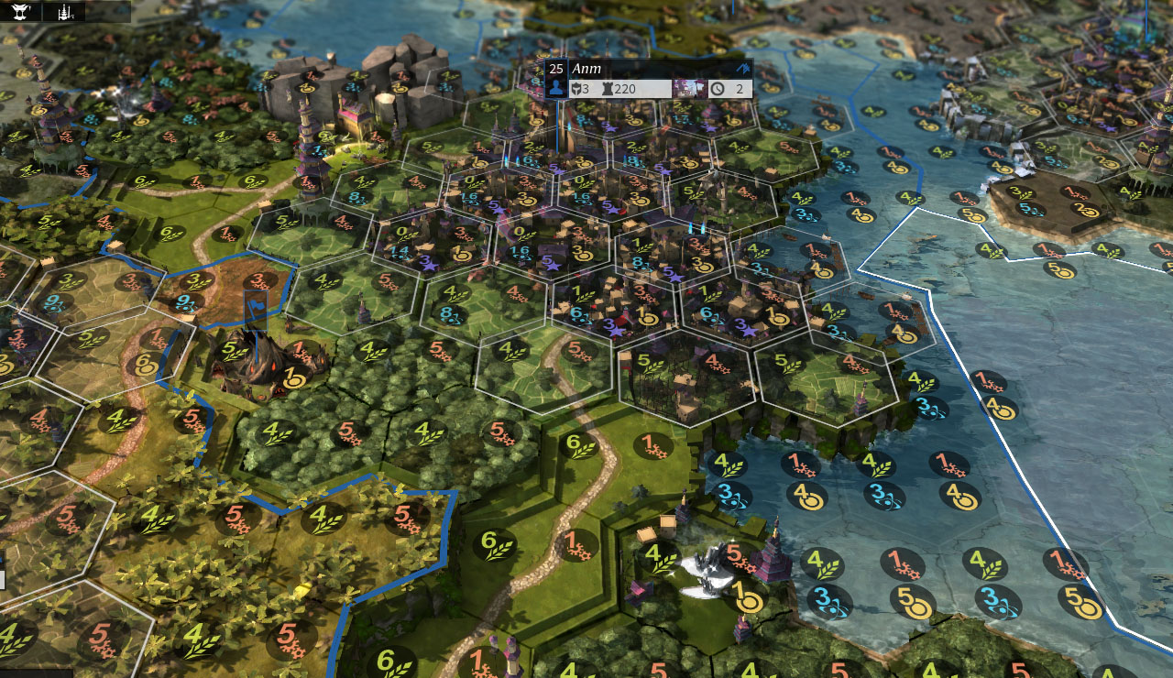

Figure - Endless Legend (2014)

The player will be tasked with planning their journey from town to town, weathering the dangers that they will face along the way. The player caravan will occupy one hex at a time, and movement on the map will be done by observing the surrounding hexes relative to the player position, and making a selection, causing the caravan to move to that adjacent hex.

Alongside trade between towns, a **desirable** feature is to allow the player to explore hexes (forest, hill, plains, ect) and gather resources that they find there (lumber, gold, food, ect) based on the equipment they have (axe, pickaxe, hoe, ect). This will introduce the new resource into the economy, allowing players to see a direct impact of their contribution toward a state of abundance.

When attacked, the combat screen will be a little window that pops up displaying a text-based RPG battle, where the player is presented with a mock battle scenario, and a readout of the outcome. The player has a chance to lose a percentage of their assets based on their readiness to receive the attack. However, successfully warding off the attack will allow players to redeem bounties based on the type & number of enemies thwarted. Players cannot lose the game during this battle, however they can lose their assets, which could potentially lead to a fail state.

When players are adjacent to a town, they may enter it as they would any other hex, and when doing so the perspective changes to the town view.

## Town

When in town, the player is presented with top-down 2d image of the town, an example would look something like the map shown in Figure 2.

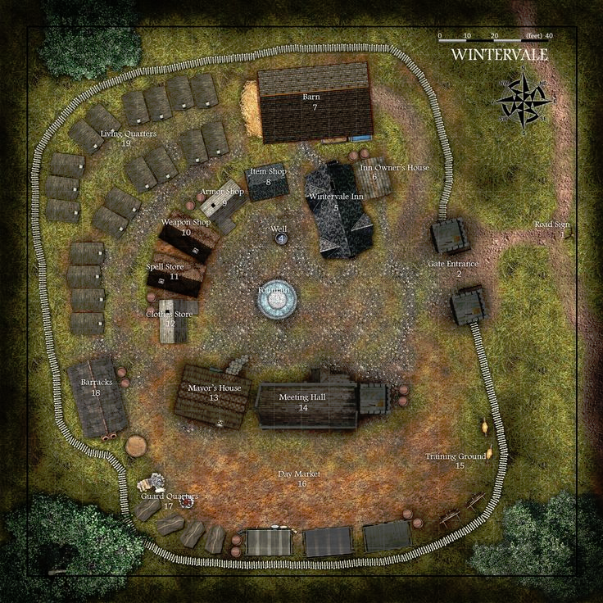

Figure - Wintervale (2009)

Players may select and navigate to the various points of interest within that town using the mouse. Visiting areas takes time, and allows the player to perform tasks such as selling goods, purchasing equipment, and accepting accounting quests. This gamespace involves one over-arching town screen, however after the players select a building, the screen transitions to that building-specific screen, where players may make their selection on what to do (buy weapons, goods, ect) before returning back to the town overview. These actions take time and will challenge the player’s knowledge of opportunity costs.

When accepting an accounting quest, there will be a specialized screen that presents where the player will be able to access all of the financial information required to solve the quest, as well as a guide detailing most of the core concepts covered in this game. Accessing this guide during a quest is not prohibited but will incur penalties.

# Example of Play:

Picture this; the player has just landed in town #2. They click on the marketplace and sell their shipment of food; 200gp goes into their cashbook, the transaction is recorded into the general journal, and the appropriate accounts are debited & credited in the general ledger. The process takes 1 hour, it is now 4pm. They view the market information for each town and see that the price of lumber in town #3 is high, while the price in their current town is very low. They then purchase 10 lumber at 10gp each, then hire 2 mercenaries at 20gp each (140gp total, accounts updated).

The player checkbook is now 50gp, and not wanting to leave with such a low balance they seek out an accounting quest. However it is now past 5pm, and business hours are over. They spend 10gp at the nearby inn to fast-forward to 8am the next day, they then check the town noticeboard to see what quests are available. One is a level 1 quest offering 80gp and 5 reputation; the player selects this. The player is then asked a simple question: “what is the definition of an Asset?” and given the option to choose one of four answers. The player answered correctly, and is rewarded with the payout as advertised, making note of the 10% Sales Tax. It is now midday.

The player then leaves town, presented with the overworld map, they mouse over the hexes and note that there is a 5% chance of ambush on each road tile, and a 15% chance through the woods. However, it will take 13 tiles on the road (26 hours) to reach town #3, or 6 tiles through the woods (12h). Feeling confident, the player decides to take the shortcut through the woods. They pass the first three hexes without incident, however it is now 6pm and sunset is imminent. The chance of ambush doubles at night, and the player has the option to camp to avoid this danger.

Feeling supremely confident, they press on into the night, and make it another two tiles before they are ambushed. The battle readout shows that while they held off most of the attackers, one got through and fled with 20% of the lumber (8 left). The player decides not to chance it further and waits till dawn, and at 6am the next day they traverse the last two tiles, and arrive in town #3. They summarily offload the lumber, and start the process again.

# Project Milestones

A rough timeline of the project schedule is as follows:

**Week 4** – Finalization of project documentation (Game design document, Project management document, Art bible, Technical document and Marketing document).

**Week 5** – Greybox template for primary game mechanics. Pitch to Design, Animation & Audio students.

**Week 6** – Alpha version ready for testing. Finalization of core mechanics.

**Week 7** – Content creation, polishing of mechanics, (re-scope if necessary).

**Week 8** – Replacing of placeholder assets with art content. Further expansion of content.

**Week 9** – Beta ready for testing, polishing of mechanics and input of player feedback, final re-scope.

**Week 10** – Polish and public playtesting

**Week 11** – Development of release version, final round of polish.

**Week 12** – Shipment of release version.

# Technical Details

This game has been produced for the major stakeholder; the West Australian Department of Education, specifically the School Curriculum and Standards Authority.

## Software

This game will be utilizing unity 5.3 as its primary engine of development, at this point in time no custom Unity plugins will be used. All of the models and 3d assets will be made in 3ds max, and the 2d assets such as town overview and map textures will be created in Photoshop and Quixel Suite. Version control for the project will be done in Github, and project scheduling in Trello. Any team-communication will be done through Slack or personal correspondence.

## Target Market

The project will be developed with the intent of teaching Year 11 high school students the majority of the Accounting and Finance content to be covered, in accordance with the West Australian ATAR Syllabus (2013). While the primary focus will be pitching toward high-school institutions and their teachers, private versions owned by students and the general public are included as a secondary.

# Publishing

The development of the retail version will involve a Unity web-player hosted on a private site, as well as direct download PC/Mac standalone versions, with a physical DVD copy upon request. Android or IOS versions are not planned at this point. Development will be tracked on my personal devblog, the specifics of which will be finalized in my project management documentation.

# References:

Accounting and Finance ATAR Course Year 11 Syllabus. (2013). Retrieved from http://scsawebapps.scsa.wa.edu.au/files/eBooks/Accounting_and_Finance_Y11_Syllabus_ATAR_PDF/

Amplitude Studios. (2014). Endless legend [Video Game]. Retrieved from <http://store.steampowered.com/app/289130/>

Coffeefery. (2009). Winterfell [Image]. Retrieved from <http://www.cartographersguild.com/showthread.php?t=8558>

Interdependence. (2016). Retrieved from http://www.econlib.org/library/Topics/HighSchool/TradeExchangeandInterdependence.html

Opportunity cost. (2016). Retrieved from <http://www.econlib.org/library/Topics/HighSchool/OpportunityCost.html>

Rieber, L. P. (1996). Seriously considering play: Designing interactive learning environments based on the blending of microworlds, simulations, and games. *ETR&D Educational Technology Research and Development,* *44*(2), 43-58. doi:10.1007/bf02300540